# **Wijn van Ervideira**

**Adega Ervideira wordt geleid door Maria Isabel Leal de Costa en haar zes kinderen. Het is in de negentiende eeuw gesticht door haar voorvader: de graaf van Ervideira. Het wijnhuis heeft een roerige geschiedenis gekend. Maar de famlie Leal de Costa heeft er een internationaal vermaard Portugees wijnhuis van weten te maken.**

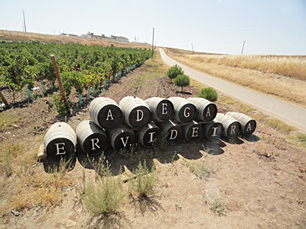

De wijngaarden van de familie Leal da Costa, op de hellingen rond het dorpje Ervideira in [Alentejo](https://anderewijn.nl/wijn_uit/Alentejo.php), kennen een lange geschiedenis. In de negentiende eeuw maakte de Graaf van Ervideira, stamvader van de huidige eigenaren, er zijn wijnen. De traditie werd tot halverwege de twintigste eeuw voortgezet door de grootvader van Maria Isabel, de huidige eigenaresse.

Met de Anjerrevolutie, een militaire staatsgreep op 25 april 1974, werden de wijngaarden van de familie onteigend. Twaalf jaar later kreeg Maria Isabel de landgoederen weer terug. Sindsdien heeft ze met hard werken en hulp van haar zes kinderen, de familietraditie hersteld. De wijngaarden liggen op glooiende hellingen. Op een bodem van rode aarde, leisteen en graniet. Met warme, droge zomers.

Tussen 1994 en 2002 werden verschillende wijngaarden opnieuw aangeplant. Volgens moderne inzichten, om betere kwaliteit wijn te kunnen maken en met respect voor de natuur. Driekwart is aangeplant met blauwe druiven als [Alicante Bouschet](https://anderewijn.nl/druif/Alicante_Bouschet.php), Aragonez ([Tempranillo](https://anderewijn.nl/druif/Tempranillo.php" \o "Spaanse wijn van de Tempranillo druif)), [Touriga Nacional](https://anderewijn.nl/druif/Touriga_Nacional.php), Alfrocheiro, Caidada Tinta , [Syrah](https://anderewijn.nl/druif/Shiraz.php) en Castellan. Witte wijn maakt de familie vooral van [Antão Vaz](https://anderewijn.nl/druif/Antao_Vaz.php), [Arinto](https://anderewijn.nl/druif/Arinto.php) en Perrum ([Palamino Fino](https://anderewijn.nl/druif/Palomino_Fino.php)). In 2002 werden de kelders geheel vernieuwd. Met moderne apparatuur voor het maken en bottelen van de wijn.

De druiven worden 's nachts machinaal geoogst en in gekoelde vrachtwagens naar de kelders vervoerd. Hier vindt de vinificatie plaats in roestvrijstalen tanks. Sommige wijnen krijgen daarna een houtrijping in de oude, koude kelders van de familie.

De Ervideira wijnen gaan inmiddels de hele wereld over. De familie verkoopt ongeveer de helft van haar wijnen in eigen land en is altijd op zoek naar nieuwe buitenlandse markten. De groeiende reputatie van de wijnen uit [Alentejo](https://anderewijn.nl/wijn_uit/Alentejo.php), geeft de familie nu de wind in de zeilen.

**Ervideira**

**Who we are**

Ervideira is one of the secular wine companies in Portugal, producing wine since 1880. It currently has the fourth and fifth generation of active producers. Ervideira have a total of 160 hectares of vineyards, distributed by family properties in Vidigueira and Reguengos.

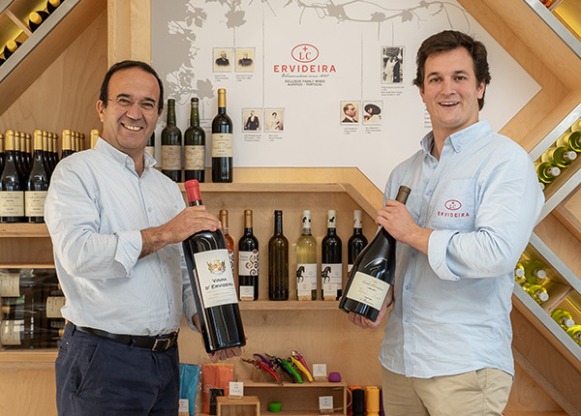

**Mission and values**

Since the beginning of our production in 1880, we have had the mission of creating truly unique and exclusive wines.

Guide by the legacy left by our great grandfather, we rely on a base of values that combines tradition and innovation: History, Pleasure, Quality, Distinction, Emotion, Gastronomy, Trust, Difference, Terroir, Tradition, Family, Exclusivity and Future.

As a working pholosophy, we always take care of hiring locally, as the company as to be a strong element helping the region. As a matter of curiosity, only job opportunities are given to those who are unemployed or looking for the first job, because in this way, in addition to being a company that generates regional stability, it does not conflict with other companies in the region, which we very much respect.

**Our History**

Our history dates back to the year 1880, when the illustrious Count D’Ervideira was honored by King D. Carlos I of Portugal for the functions of public and political man, and also for his contribution to the social work in the region. He was the one starting the production of wine in Évora.

**Conde d'Ervideira**

Political, Philanthropist and Visionary

José Perdigão Rosado de Carvalho was born in Évora in 1862. During his life he was dedicated himself to politics and public service. He served as Provedor in Santa Casa da Misericórdia and Real Casa Pia in Évora, and founded the newspaper “Distrito de Évora”.

At the age of 24 he was honored with the title of Viscount of Ervideira, and was later elevated to Count D’Ervideira by the King D. Carlos I of Portugal.

As governor, he was responsible for the implementation of infrastructures as: fountains, drinking fountains, schools and churches.

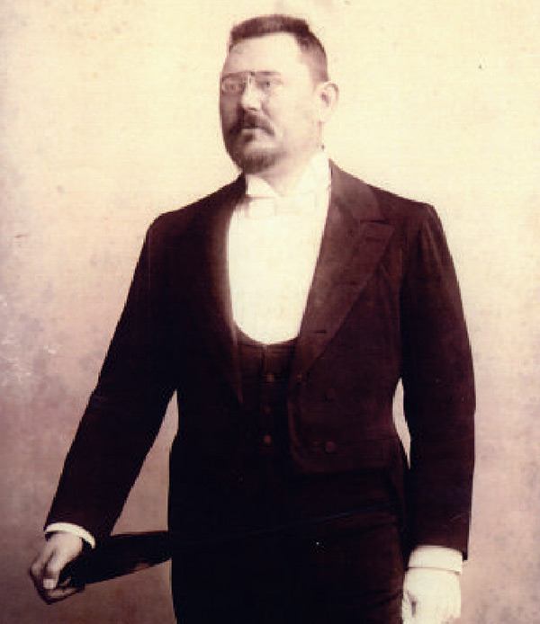

As an entrepreneur, he increased his already vast estate of agriculture land, invested in structures, and helped to mechanize and modernize agricultural techniques. He applied the remaining funds, in social work in the Hospital of the region and Santa Casa da Misericórdia.

In the dark periods where people had no food, he installed in one of his properties a “everyone kitchen” where everyone had free access to diferente meals.

The character and work of Count D’Ervideira marked the region deeply. He was always defended the unproctected, he was generous, integral and innovative. These values have been handed down from generation to generation and today are the basis of Ervideira brand.

**A Legacy of passion**

Behind every Ervideira wine, there is a history. Theses wines are a tribute to a man who loved and respected the land, the sun, the vineyard and the wine.

We create wines with character, structure and complexity, to match with elegance, softness and subtlety – characteristics of Count D’Ervideira himself!

Today, the average annual production is around 800,000 bottles of wine, obtained exclusively from the grapes harvested in our vineyards. The vineyards are planted in the sub-regions of Reguengos de Monsaraz and Vidigueira.

Besides the representation in the nacional market, Ervideira also exports to more than 20 countries around the world.

In Ervideira we are all colleagues and we are all invited to work with passion, dedication and innovation.

**A legacy of Innovation**

Since the beginning, innovation is part of Ervideira’s DNA. We never had afraid to risk and walk over territories never explored before. We combine tradition with revolution and create each wine with its own personality.

The centuries pass and history repeats itself, we want Ervideira to be a simple and solid company, but with a tremendous beauty.

Our irreverente spirit became pioneer in the region, the sector and in several initiatives.

**1991**

The first plantation of Touriga Nacional in Alentejo



**2000**

The first harvest at night, and transport of grapes in refrigerated trucks



**2002**

A primeira produção de Espumante com certificação no Alentejo sendo atualmente o maior produtor do Alentejo

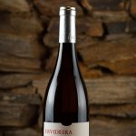

**2009**

The first production and certification of a white wine from a red grape, our Invisible



**2013**

The first using the helix cork in the wines (easy opening stopper, 100% cork)

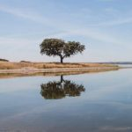

**2015**

The first submerging wines 30 meters deep, on the large lake of Alqueva, to create our Water Wine

**Passion for the method**

The wine production process is focuses on the maintenance, essence and quality

The harvest is done at night when there is no sun exposure and temperatures are lower, allowing the grapes to maintain their properties.

The transport to the winery is chilled to preserve the charactertistics of the fresh grape. After the grapes will be subjected to a highly controlled vinification process.

It is also in the winery that we will combine technology and modernity with knowledge and tradition. The wines begin by fermenting in stainless steel vats, then going to stage in oak barrels from French and Hungarian origins. During this period, the wines become even richer, contracting new tones and flavors.

ERVIDEIRA

7200 - 042 Reguengos de Monsaraz, Portugal

